Project Title: Income Tax Calculator
Project Description: Students need to store the record of tax payers through file handling in which you can perform following options:
1. Add New Record
2. List all Tax Payers
3. Search Record
4. Edit Record
5. Delete Record

Income Tax Calculator

The first step to understand the workings of Income Tax in India is to be aware of the taxation slabs released each financial year by the Indian Government. The taxation slabs for the financial year 2014-15 for General tax payers and Women: –
Slab | Income Slab (Rs.) | Income Tax Rate
0 | 0 to 2,50,000 | NIL
I | 2,50,001-5,00,000 | 10%
II | 5,00,001-10,00,000 | 20%
III | 10,00,001 and above | 30%

If you fall in Slab I, tax will be deducted on the amount that exceeds Rs. 2,50,001/- . Similarly, tax for Slab II and Slab III will be calculated for the amount that exceeds Rs. 5,00,001/- and Rs. 10,00,001/- respectively. The same principle also applies to the tax slabs for senior citizens (Aged 60 years but less than 80 years):-
Slab | Income Slab (Rs.) | Income Tax Rate
0 | 0 to 3,00,000 | NIL
I | 3,00,001 to 5,00,000 | 10%
II | 5,00,001 to 10,00,000 | 20%
III | 10,00,000 and above | 30%

India Income tax slabs 2014-2015 for very senior citizens (Aged 80 and above):-
Slab | Income Slab (Rs.) | Income Tax Rate
0 | 0 to 5,00,000 | NIL
I | 5,00,001 to 10,00,000 | 20%
II | 10,00,000 and above | 30%

Now, find out the variables needed for this program calculating INCOME TAX.
Here we find out two variables for this program. First is INCOME of the person which is to be entered by the user. Second is the TAX to be calculated by the program to be payable by the person.
we have INCOME ,TAX. (i.e. Two Variables)
Now decide the data type for the variables INCOME ,TAX.
Whenever we are using anything related to money, we should use float or double .float can hold smaller values compared to double. Hence we will omit float. Select double as our data type.
double INCOME,TAX;
Variables and data type selection done.
Interactive means the program will not have any hard coded values assigned to variables but user has to provide them.
To get values from the user screen we have a function called scanf() which will help us to scan values entered by the user by keyboard and visible on the screen.
We cannot expect that user should enter values in the sequence blindly without knowing what to enter. For that purpose we should guide the user to enter expected values by displaying message.
(E.g. ENTER THE INCOME OF A PERSON : ) than scan the value entered for Income in INCOME and so on.
printf("THE INCOME TAX PAYABLE OF A PERSON IS : %.2lf",TAX);
Here we are using %.2lf instead of %f so that the Amount is printed to Two Decimal Digits.
Note: – Remember whenever you are scanning or printing the values of double be careful to write %lf instead of just %f. Because %lf is used for double data type and %f is used for float data type.
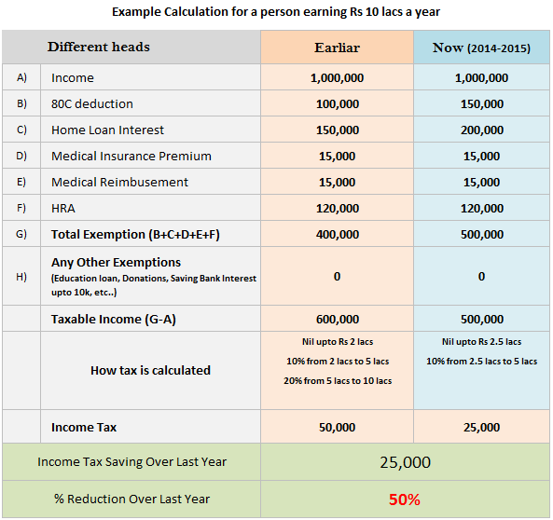
You have to store the record of your tax payers through file handling in which you can perform following option.
- Add New Record
- List all Tax Payer
- Search
- Edit
- Delete Record

• INSERT Module:
An admin can insert the new data of a customer, he/she can enter the details of Contact i.e. Name, Contact no., address etc.
Student need to store all record permanently , using the concept of file handling which play an important role in the project because all modules will use the same file.
- Add New Record
- List all Tax Payer
- Search
- Edit
- Delete Record
Enter your choice: 1
DISPLAY/LIST Module:
This module helps Admin to retrieve all information of all contacts in one go. Student will use file handling concept where all data already saved in the record file. With the help of File input and output function; student can easily display all data.
- Add New Record
- List all Tax Payer
- Search
- Edit
- Delete Record
Enter your choice: 2
SEARCH Module:
Searching by Name will return all the tax details. This Module requires the concept of comparison operator. While comparing, if the condition is true then details of student will display on the screen otherwise display message “No Record Found.”
- Add New Record
- List all Tax Payer
- Search
- Edit
- Delete Record
Enter your choice: 3

EDIT Module:
Admin can update the data of any contact. Software will give the options for modifying any attribute of contact records. Here, Student needs to use two files. One is original file where all records are already available and second temporary file where updated data is added with previous data of other Record.
After this process, student will discard original file and rename the temporary file to previous file name.
- Add New Record
- List all Tax Payer
- Search
- Edit
- Delete Record
Enter your choice: 4

DELETE Module:
Admin can delete the data of any contact by enter his/ her name. And for verification, admin can use the DISPLAY/LIST Module where he can check whether the record of book is deleted or not. In this case, student will use two files and where he/ she will copy the data from old file to another expect that data which he/she wants to delete. So, student will use the concept of copying data from one file to another.
- Add New Record
- List all Tax Payer
- Search
- Edit
- Delete Record

Enter your choice: 5

